1.

#pragma warning (disable:4996)

#include <stdio.h>

int main()

{

double d[20], tmp;

FILE* fp;

for (int i = 0; i < 20; ++i)

{

scanf("%lf", &d[i]);

}

fp = fopen("fdata.txt", "w+");

for (int i = 0; i < 20; ++i)

{

fprintf(fp, "%lf ", d[i]);

}

fseek(fp, 0, SEEK_SET);

for (int j = 0; j < 10; ++j) {

fscanf(fp, "%lf", &tmp);

printf("%lf ", tmp);

}

fclose(fp);

return 0;

}

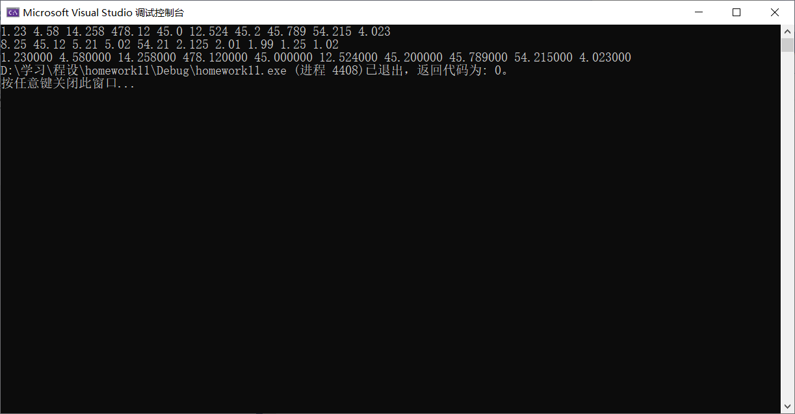

2.

#pragma warning (disable:4996)

#include <stdio.h>

int main()

{

char s[150];

FILE* fp;

int i = 0;

while ((s[i] = getchar()) != '#')

{

if (s[i] >= 'a' && s[i] <= 'z')

s[i] = s[i] - 'a' + 'A';

++i;

}

fflush(stdin);

s[i] = '\0';

fp = fopen("upper.txt", "w+");

fprintf(fp, "%s", s);

fseek(fp, 0, SEEK_SET);

fscanf(fp, "%s", s);

printf("%s", s);

fclose(fp);

return 0;

}

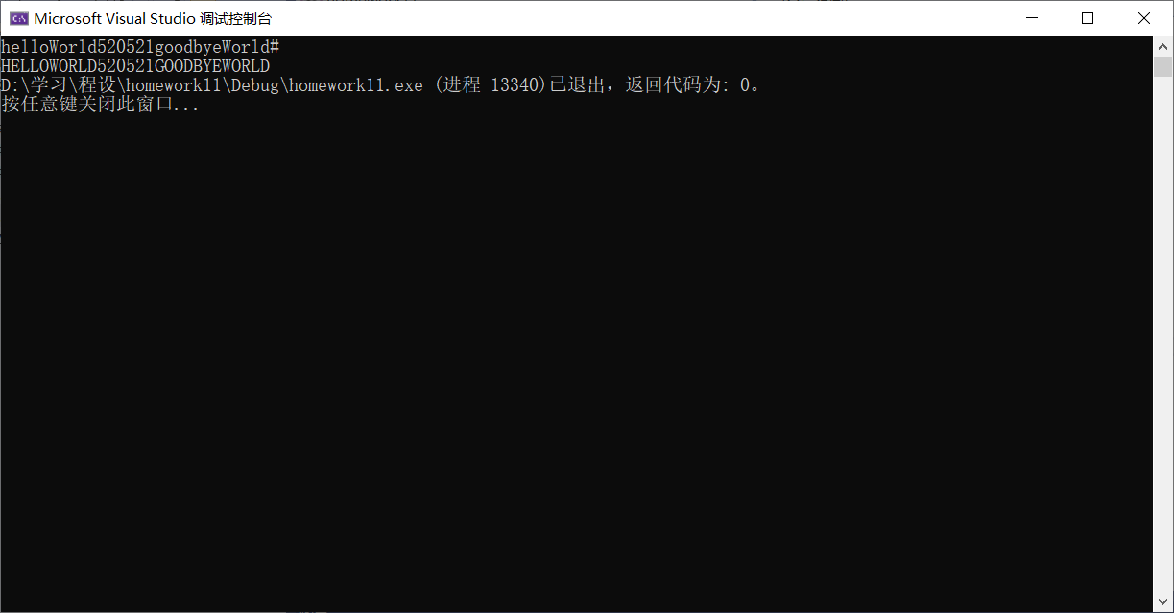

6.

#pragma warning (disable:4996)

#include <stdio.h>

typedef struct student {

char num[7];

char name[8];

char gender[3];

char age[5];

char grade[9];

} STUDENT;

int main()

{

STUDENT sts[10] = {

{"101", "Zhang", "M", "19", "95.6"},

{"102", "Wang", "F", "18","92.4"} ,

{"103", "Zhao", "M", "19", "85.7"},

{"104", "Li", "M", "20", "96.3"},

{"105", "Gao", "M", "19", "90.2"},

{"106", "Lin", "M", "18", "91.5"},

{"107", "Ma", "F", "17", "98.7"},

{"108", "Zhen", "M", "21", "90.1"},

{"109", "Xu", "M", "19", "89.5"},

{"110", "Mao", "F", "18", "94.5"}

}, st;

FILE* fp;

fp = fopen("stu.dat", "w+b");

fwrite(&sts, sizeof(STUDENT), 10, fp);

fclose(fp);

fp = fopen("stu.dat", "r+b");

printf("num name gender age grade \n\n");

for (int i = 0; i < 10; ++i)

{

fread(&st, sizeof(STUDENT), 1, fp);

printf("%-7s %-8s %-5s %-5s %-9s\n", st.num, st.name, st.gender, st.age, st.grade);

}

fclose(fp);

return 0;

}

